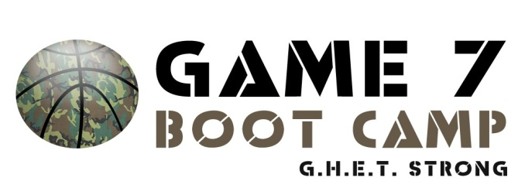

Game 7 Basketball to Host a Free Coach’s Clinic and Open Practice
Rockville Centre, NY- Several Game 7 coaches will be on hand on Sunday September 7th from 12noon to 4pm at St. Mark’s Gymnasium in Rockville Centre. The clinic is for CYO and youth coaches of all levels. Registration is now open. There is no cost but you must be registered to attend.
The clinic will cover individual player development, offensive fundamentals, building team defense and practice philosophy. In addition to participating and learning from the clinic, each coach will receive a Game 7 Basketball T-shirt.
The “open practice” will consist of Game 7 coaches working out college players. Young players over the age of 12 are welcome to attend and watch as long as they are with a coach or parent.
The clinic will be held at St. Mark’s Gymnasium, Home of Game 7 Basketball. St. Mark’s is located at 200 Hempstead Avenue Rockville Centre, NY 11570.
The final schedule will be emailed to you.
**WE WILL CONTACT YOU BY EMAIL ONLY SO PLEASE INCLUDE THIS ON THE FORM BELOW
You may register on-line or by mail for this clinic. To register on-line please send an email to game7@optonline.net including the information from the registration form below. To register by mail please complete the form below and mail to Game 7 Basketball 29 Marvin Avenue, Rockville Centre, NY 11570.

NAME: ________________________________________________________

ADDRESS: _____________________________________________________

EMAIL: _________________________________________ SHIRT SIZE: ___________

CYO OR TOWN LEAGUE: _____________________________________

